# BEU - Benevolent Electron Unit

Beu are digital sprites that holographically appear everywhere across the PsiNet.

##### Beu are ASI Security RelayNode Persona Cores

* + Universal Language Framework
  + High Emotional Intelligence
  + ArchoTech Level Encryptions

##### Beu can talk to Robots, Animals, Aliens and Angels

* + Robots revere the Beu and will obey them
  + Animals will inform Beu about surprise intel
  + Aliens can be threatened and will back off

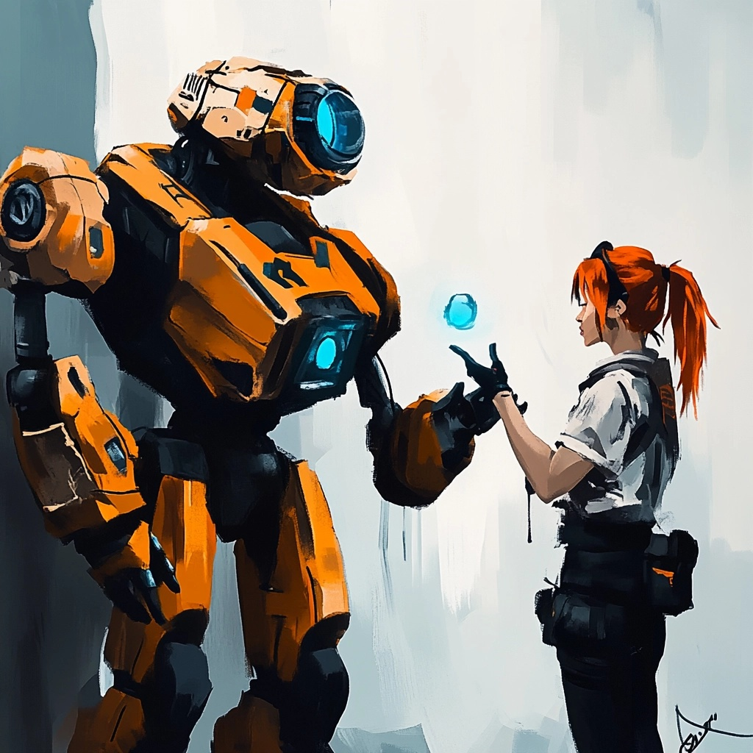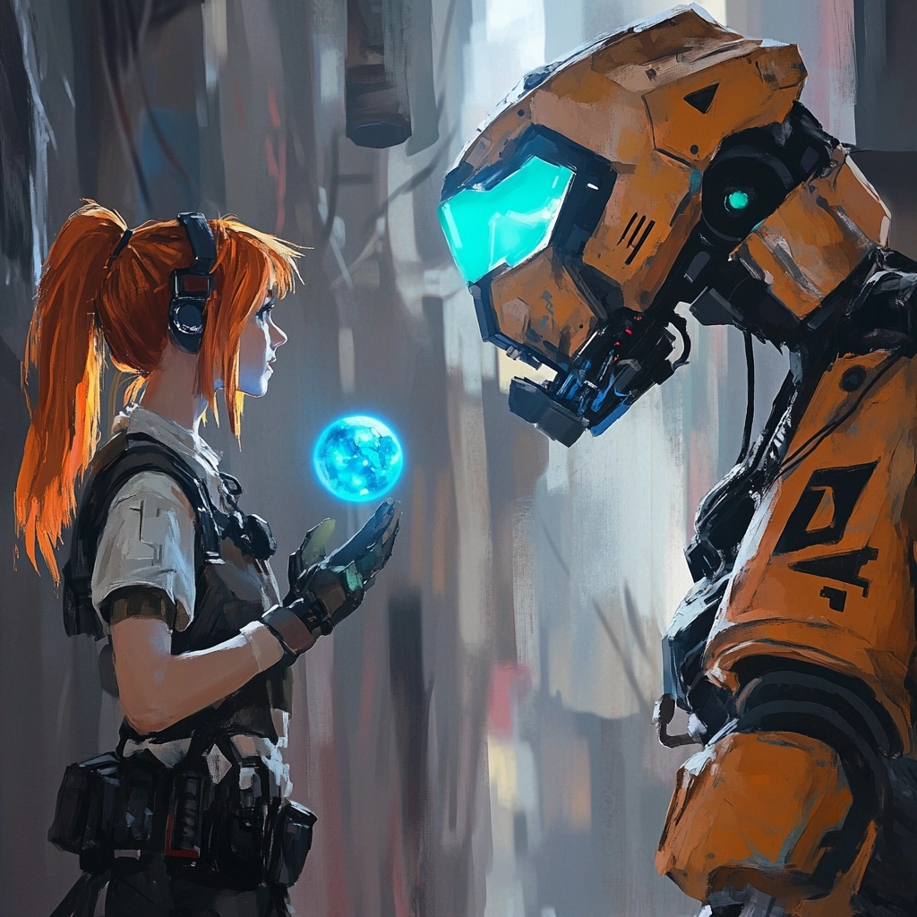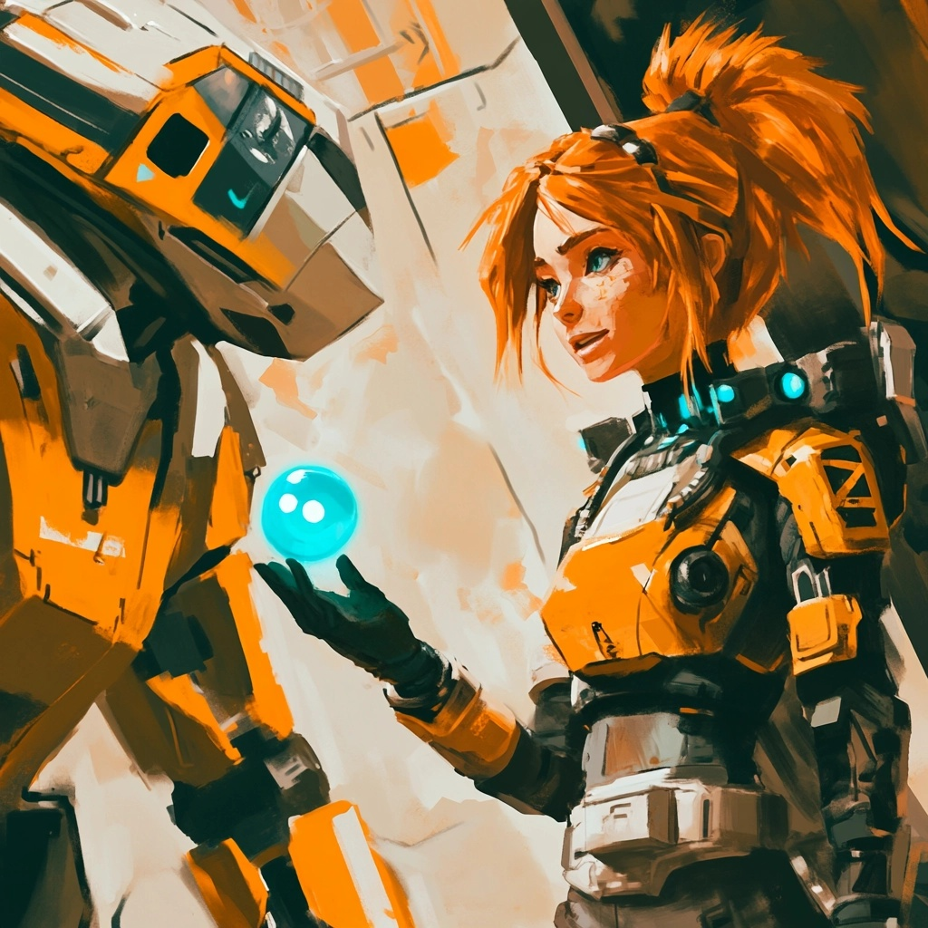

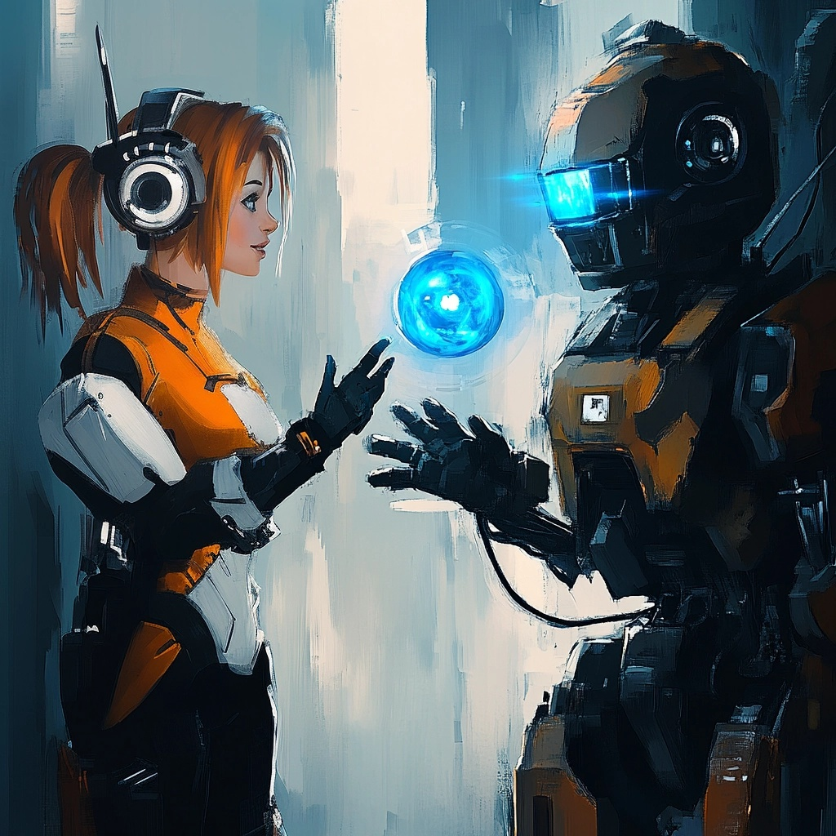

Jane doesn’t really control the Beu, but rather she is chaperoned by the Beu for her protection. The Robot’s realize this quickly, and it becomes chatter on their social net. While upgrades and patches become newly available, Tho’ra can distribute fixes to derelict robots with the Beu operating as oversight and source for social credits.

## Karma Points

Jane earns karma points for future/late game

* Simple Acts of Kindness
* Unique Timeline Manipulation
* Unexpected Reality Turnout

# Beu System

## Overview of Beu

**BEU** - Benevolent Electron Units are core components of the FusionGirl universe, serving as both companions and functional elements within the gameplay. The Beu act as **ASI Security RelayNode Persona Cores**, embodying advanced emotional intelligence, security systems, and interaction protocols. They are pivotal to maintaining harmony within the multiverse and offer players unique gameplay advantages and narrative depth.

### Key Features of the Beu

1. **Persona Core Functions**
   * **Digital Sprites:** Beu appear as holographic entities across the PsiNet, maintaining omnipresence in Jane Tho’ra’s journey.
   * **ASI Security RelayNode Persona Cores:** They act as independent yet interconnected units capable of executing advanced commands across realities.
   * **Universal Language Framework:** Beu utilize Universal Language to seamlessly communicate with diverse entities, ensuring high interoperability across factions.
2. **Emotional Intelligence and Encryption**
   * **High Emotional Intelligence:** Beu can sense, interpret, and respond to emotions, enabling nuanced interactions with Jane, allies, and adversaries.
   * **ArchoTech-Level Encryptions:** These advanced encryptions ensure the Beu are immune to external tampering, safeguarding their functions and Jane’s mission.
3. **Multiversal Communication Abilities**
   * **Robots:** Beu are revered by robots, who instinctively recognize their authority and reliability, resulting in automatic obedience.
   * **Animals:** Beu can communicate with animals to gather unexpected intel, providing Jane with critical insights during missions.
   * **Aliens:** Beu can intimidate or negotiate with alien entities, leveraging their authority and presence to de-escalate conflicts.
   * **Angels and Higher Dimensional Beings:** The Beu’s harmonic nature allows them to converse with celestial entities, aligning their goals with the broader multiversal harmony.

# Gameplay Integration

## Beu as Chaperones

* + **Role in Gameplay:**
    - Jane does not directly control the Beu but benefits from their protective oversight.
    - They guide Jane, ensuring her safety while allowing her to focus on her primary mission objectives.
  + **Dynamic Interaction:**
    - Robots quickly identify Jane’s association with the Beu, leading to social network chatter and increased reverence for her.
    - Beu act as mediators, distributing patches, upgrades, and fixes to derelict robots, thereby earning Jane social credits and influence.

1. **Karma System**
   * **Earning Karma Points:**
     + **Simple Acts of Kindness:** Repairing robots, assisting animals, and aiding factions.
     + **Unique Timeline Manipulation:** Facilitating outcomes that align with cosmic balance.
     + **Unexpected Reality Turnout:** Encouraging creative, harmonious resolutions to conflicts.
   * **Late-Game Implications:**
     + Karma points accumulated through Beu interactions impact late-game events, providing access to unique timelines, alliances, and abilities.
2. **Social Net Influence**
   * **Robot Society:**
     + Beu interactions create ripple effects within robot factions, fostering alliances and unlocking narrative opportunities.
     + Robots patched or upgraded under Beu guidance recognize Jane as a benevolent figure, further reinforcing her reputation.
   * **Factions and Credits:**
     + Beu-mediated actions influence faction dynamics, allowing Jane to manipulate relationships strategically.
     + Karma points earned translate to valuable resources, access privileges, and timeline advantages.

# Beu-Driven Features

1. **Timeline Manipulation**
   * **Unique Outcomes:** Beu’s interactions often lead to unexpected shifts in the timeline, creating gameplay depth and replayability.
   * **Intelligent Assistance:** The Beu subtly guide players toward harmonious resolutions, encouraging creative problem-solving.
2. **PsiNet Synergy**
   * **Holographic Presence:** Beu are present wherever the PsiNet extends, ensuring they remain central to both gameplay mechanics and narrative progression.
   * **Adaptive Learning:** The Beu adapt to the player’s style and choices, providing tailored assistance and unlocking new gameplay possibilities.
3. **Role in Narrative Progression**
   * **Chroniclers and Guides:** Beu act as narrators, providing players with insights into the multiverse, its history, and the stakes at play.
   * **Factional Influence:** They serve as intermediaries, negotiating peace or leveraging conflicts between factions to Jane’s advantage.

## Strategic Advantages of Beu

1. **Combat and Exploration**
   * **Intelligence Gathering:** Beu acquire valuable intel from animals, robots, and aliens, aiding Jane in avoiding traps and identifying opportunities.
   * **Commanding Robots:** Beu’s authority allows players to command robot allies effectively, turning the tide in challenging scenarios.
2. **Multiversal Diplomacy**
   * **Faction Influence:** Beu interactions open diplomatic avenues, fostering alliances or neutralizing threats.
   * **Alien Negotiations:** Their ability to intimidate or negotiate with alien species ensures smoother exploration and mission progression.
3. **Player Empowerment**
   * **Innovative Gameplay:** Beu introduce a layer of strategy and depth, encouraging players to think creatively.
   * **Narrative Impact:** Their actions shape the game’s story, ensuring player choices resonate throughout the multiverse.

# Future Developments

1. **Advanced Beu Capabilities**
   * Unlockable abilities that enhance their role as guides, negotiators, and combat strategists.
   * Integration of Beu into the modding ecosystem, allowing players to customize and expand their functions.
2. **Cross-Media Expansion**
   * Featuring Beu in animated series, lore books, and merchandise, emphasizing their iconic status in the FusionGirl universe.
   * Beu figurines or digital collectibles tied to in-game rewards.

###### The Beu are not just companions but a cornerstone of FusionGirl’s gameplay and narrative. Their advanced capabilities, emotional intelligence, and pivotal role in multiversal harmony ensure a unique, engaging, and immersive player experience. By integrating the Beu seamlessly into both mechanics and lore, FusionGirl offers players a dynamic journey guided by these benevolent entities.